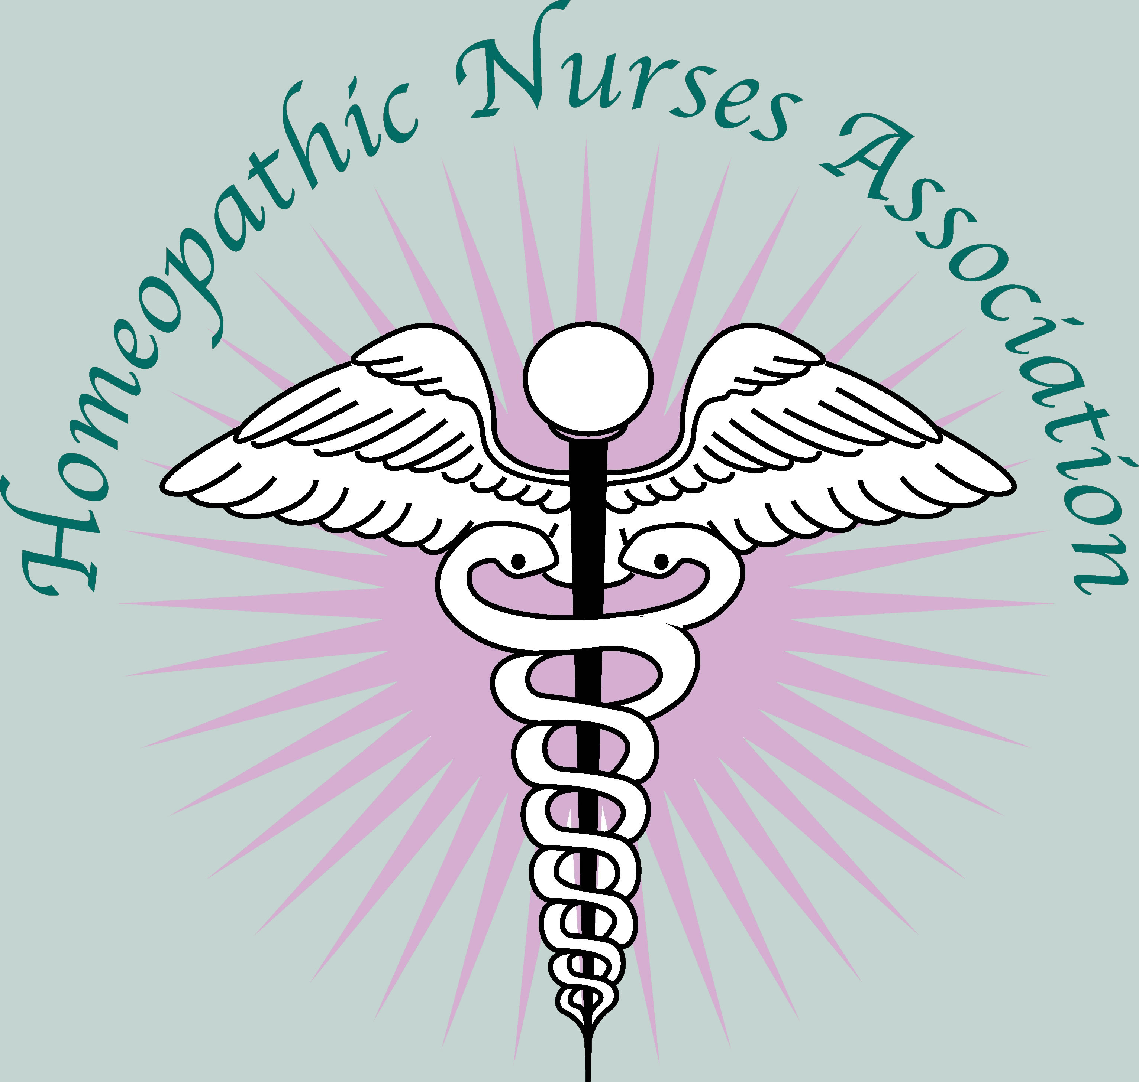

The Homeopathic Nurses Association (HNA) is proud to announce our continuing the Scholarship program for 2019! This scholarship is for $250 and open to active HNA members. It is to be used for homeopathic education classes, conferences, or workshops. Requirements for applicants include writing a one page essay on how this scholarship will facilitate advancement of their homeopathic nursing career.

This scholarship program began from a generous donation made by Wells Fargo Community Grant Program and through a nomination made by Ms. Marge Roberts, CEO at Newton Laboratories, Inc. HNA has granted scholarships to nurses in the U.S., Canada, and Haiti.

Those wishing to apply can send in their submissions by email to Kathy Zimmerman PhD, FNP-BC, APHN-BC, CCH, President of HNA: nursehomeopath@outlook.com. The HNA Board of Directors will decide the winner based on completed essays and a lottery pick of those submissions.

The Homeopathic Nurses Association is dedicated to supporting all nurses who are interested in homeopathy. Visit our website to learn more and to join: nursehomeopaths.org

