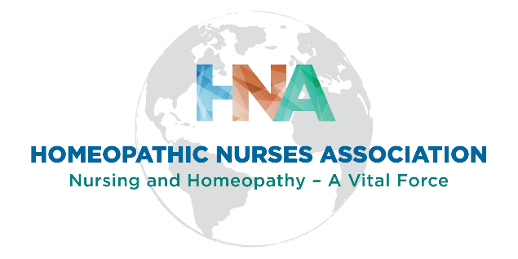

Advancing Nursing Leadership and Presence in Homeopathy Scholarship Application

Deadline Date for Submission: February 18, 2022

The purpose of this annual $500.00 scholarship is to support HNA Full members who want to pursue activities that demonstrate their leadership as a homeopathic practitioner and/or to promote the professional presence of homeopathy.

The scope of this scholarship includes financial assistance for relevant continuing education conferences and seminars, travel/fees for presentations at conferences, research and publication support, and membership fees for homeopathic/nursing professional organizations.

Scholarship Applicant - Complete Below

Name:

Credentials:

Mailing Address:

Email:

Telephone:

Attach the following to this Application

1. Brief Biography (150 words)

2. A Video – No more than Three Minutes and submitted in Mp4 Format

Here are Prompts for Your Video

- Choose a place where you can speak up and act natural.
- Don’t record where it is noisy.
- Be prepared enough that you don’t need to read from cards or a paper.
- Be sure to smile.
- And, remember less is more.
- First, tell us something interesting about yourself.
- Then tell us why you believe you are a leader (e.g., how you work with others and/or your leadership accomplishments).
- Identify three of your personal/professional leadership qualities.
- Also share how you will use your leadership skills to advance nursing and homeopathy.
- And then tell us how you plan to use the scholarship monies (give us one specific example).
Find some examples below.
- Registration for relevant continuing education
- Fees needed to present on homeopathy at conferences
- Research and publication support
- Membership fee for homeopathic/nursing organization
- Or others that promote homeopathic leadership and presence
- Finally, HAVE FUN!
Signature:_______________________________________ Date:___________

Should you be awarded the scholarship, check below if you are willing to provide a personal statement about what it meant to you to receive the scholarship. This will be posted on the HNA website and other HNA informational documents to promote the HNA Scholarship Program.

Yes, I am willing to submit a brief personal statement.

Signature:________________________________________ Date:_____________

Please submit your Scholarship Application to:

Dr. Maryann Ivons, HNA Scholarship Committee Chair. Use HNA Scholarship on your Subject line.
mernivons@gmail.com

If you have any questions you may contact Dr. Ivons at her email address.

For HNA Scholarship Committee Chair

Receipt of Application: Date: ___________________

